Assignment 2 Digital and Analog Input & Output

Released Date: September 26th
Version 1.0
Format: Name the document in the combination of name、ID and No. of Assignment.
Example: Ping Yi_30802023_Assignment2.doc
Email the document to “pingy@wxit.edu.cn” before Oct 1st.
Font’s requirement:
Chinese Letter “宋体五号”
English and digit Letter “Time New Roman 五号”

Task 1 Specify and mark Arduino Uno onboard Digital and Analog Pins.
任务1 描述和标注Arduino Uno板上的数字引脚和模拟引脚。
数字引脚
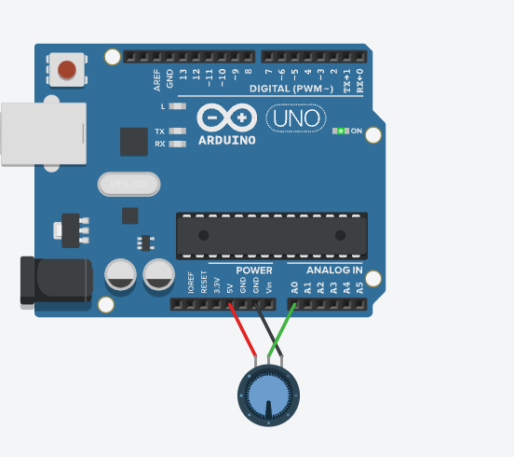
模拟引脚
数字引脚： 数字I/O Arduino UNO板有14个数字I/O引脚，0到13。(其中6个提供PWM(脉宽调制)输出)，这些引脚可配置为数字输入引脚，用于读取逻辑值(0或1)或作为数字输出引脚来驱动不同的模块
模拟引脚：Arduino UNO板有六个模拟输入引脚，A0到A5。这些引脚可以从模拟传感器(如湿度传感器或温度传感器)读取信号，并将其转换为可由微处理器读取的数字值

Fig 2 Arduino Uno Board

Task 2 One LED is linked with the digital pin, set up a circuit to use a button (or two) to control the on and off state of the LED. Draw the circuit in TinkerCAD, make the executable codes for the function.
任务2 一个LED与数字引脚相连，设置一个电路，用一个（或两个）按钮来控制LED的开启和关闭状态。在TinkerCAD中绘制电路，编写功能的可执行代码。

Fig 2 Circuit

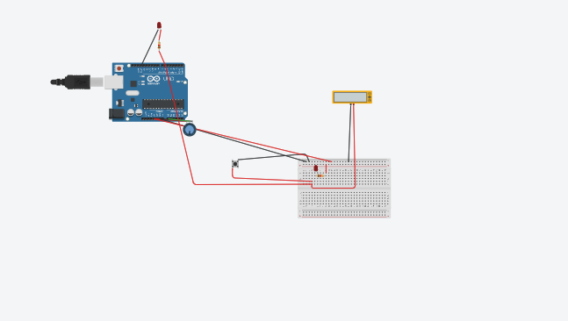
- int ledPin = 3;
- int potPin = A0;
- void setup() {
- // setup pin modes
- pinMode(ledPin, OUTPUT);
- pinMode(potPin, INPUT);
- }
- void loop() {
- // read the value of the pot and store it as potValue
- int potValue = analogRead(potPin);
- // turn led on and wait for the time equal to potValue
- digitalWrite(ledPin, HIGH);
- delay(potValue);
- // re-read the value of the pot and store it as potValue
- potValue = analogRead(potPin);
- // turn led off and wait for the time equal to potValue
- digitalWrite(ledPin, LOW);
- delay(potValue);
- }

